INVOICE MANAGEMENT SYSTEM
Application Documentation
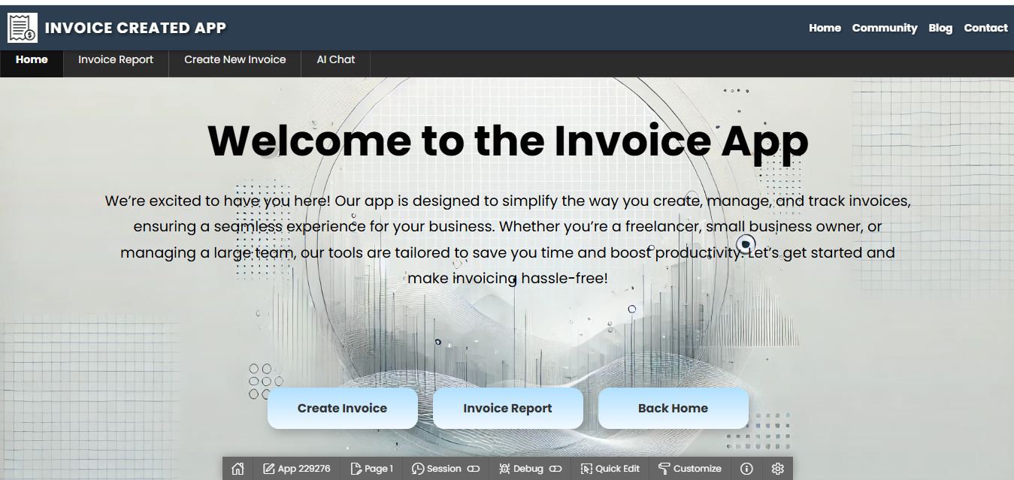
Developed By: Md Danish Iqbal
Technology: Oracle APEX & Oracle Database
Date: 07 February 2026

1. Project Overview
The Invoice Management System is a comprehensive web-based application developed using Oracle APEX and Oracle Database to manage supplier, buyer, product, and invoice transactions efficiently. The system enables structured invoice creation, automated GST calculation through database triggers, secure user authentication, and generation of print-ready invoice reports.

Additionally, the integration of an AI-powered Chat Agent enhances the application by enabling users to retrieve invoice, supplier, product, and financial information through conversational queries. This transforms the solution from a traditional invoice application into an intelligent, data-driven, and conversational financial management platform.

2. Technology Stack
- Oracle APEX
- AI Agent Chat
- RAG / AI Integration
- Oracle SQL
- PL/SQL
- Database Triggers
- Custom Authentication Function
HTML & CSS (UI Customization)

3. Application Flow
User Login → Create Invoice → Add Supplier → Add Buyer → Add Product → GST Calculation (Trigger) → Invoice Generation → Print Report
Application Flow

4. Database Design

USER_INVOICE
Stores user authentication details such as username and password.

SUPPLIER_DETAILS
Stores supplier master data including GSTIN, PAN, and contact details.

BUYER_DETAILS
Stores buyer and consignee information for invoice processing.

BANK_DETAILS
Stores bank details used in invoice payment processing.

OTHER_DETAILS
Stores invoice-level details like invoice date, payment terms, and additional charges.

PRODUCT_DETAILS_HEADER
Stores product master information.

PRODUCT_DETAILS_LINE
Stores invoice line items including quantity, price, GST, and total amount.

5. Business Logic Implementation

TOTAL_PRICE_TRIG
Automatically calculates TOTAL_PRICE = QUANTITY × UNIT_PRICE before insert or update.

TOTAL_PERCENTEGE_TRIG
Automatically calculates GST_TAX_AMOUNT = QUANTITY × UNIT_PRICE × GST% / 100.

AUTH_INV Function
Validates username and password from USER_INVOICE table and controls login authentication using apex_util.set_authentication_result.

6. Security Features
- Custom authentication function
- Controlled login validation
- Database-driven validation logic

7. Key Features
- Automated GST Calculation
- Dynamic Invoice Generation
- Professional UI Design
- Modular Database Architecture
- Print-Ready Invoice Report

8. Future Enhancements
- Role-based access control
- AI chat for user Queries
- Email invoice functionality
- Dashboard analytics
- REST API integration
- PDF auto-generation and email feature
9. AI Chat Agent Integration
9.1 Overview
The application includes an integrated AI Chat Agent capable of answering invoice-related queries in real time.
The AI agent interacts with invoice data and provides dynamic responses based on user questions.

9.2 Purpose of AI Chat
- Improve user experience
- Reduce manual searching
- Provide quick invoice insights
- Enable conversational access to invoice data
- Support decision-making with real-time responses

9.3 AI Capabilities
The AI Chat Agent can answer queries related to:

Invoice Information
- Total number of invoices
- Invoice by invoice number
- Invoice date details
- Invoice status
- Total invoice amount
Supplier Queries
- Supplier details by name
- GSTIN and contact details
- Invoices related to specific supplier
- Supplier-wise total billing amount
- Buyer Queries
- Buyer information
- Buyer-wise invoice history
- City/state-based invoice filtering
Product & Line Items
- Product-wise sales
- Quantity sold
- Unit price details
- GST tax amount per product
- Total invoice calculation

Financial Queries
- Total GST collected
- Total invoice value
- Invoice summary report
- Monthly billing summary
9.5 Technical Implementation
- AI Chat UI created in Oracle APEX
- Backend integration with invoice tables
- Dynamic SQL queries for data retrieval
- Business logic validation
- Real-time response display
9.6 Business Value
- Reduces report dependency
- Faster decision making
- Improves operational efficiency
- Intelligent invoice analytics
- Modern AI-enabled application
9.7 Example Questions Supported
- You can add examples like:
- "What is the total invoice amount?"
- "Show invoices for Supplier ABC."
- "How much GST was calculated?"
- "Give me product-wise total sales."
- "Show buyer details for invoice INV1001."
- "What is the total billing for this month?"
Application Sanp Shot
Login Page:- 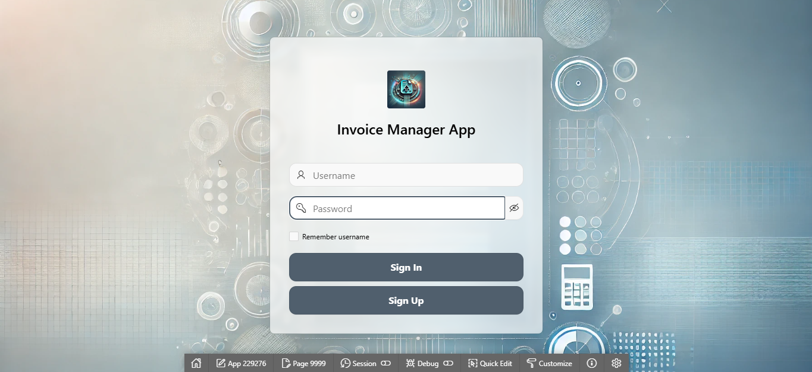
Home Page

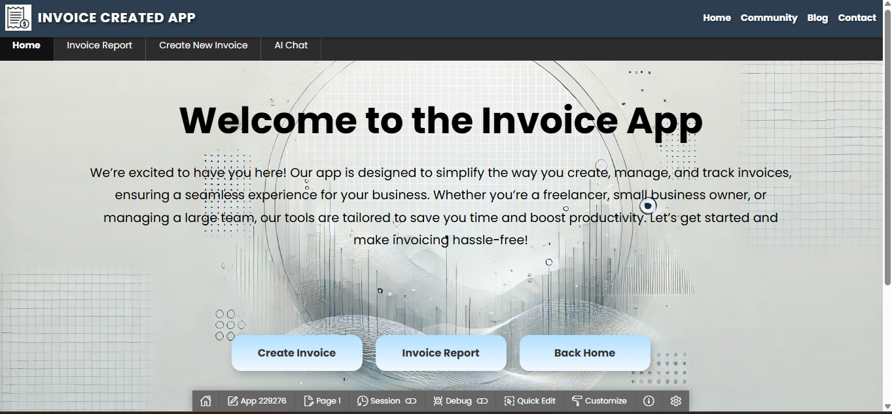
Create Invoice Form
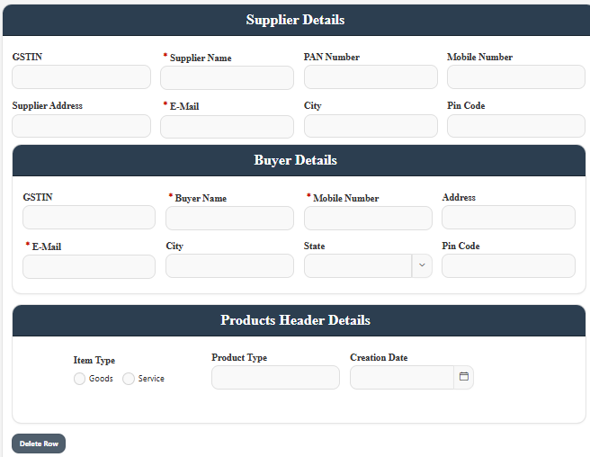
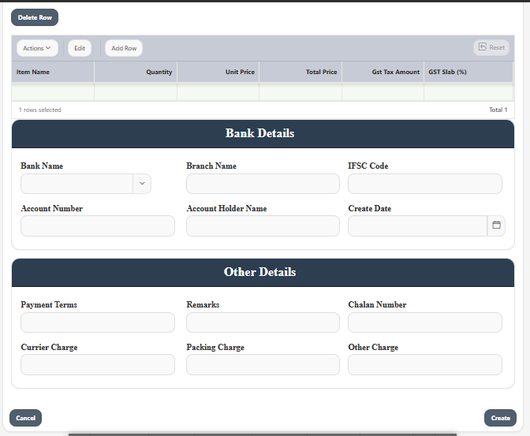
USER Invoice Form – FillUP
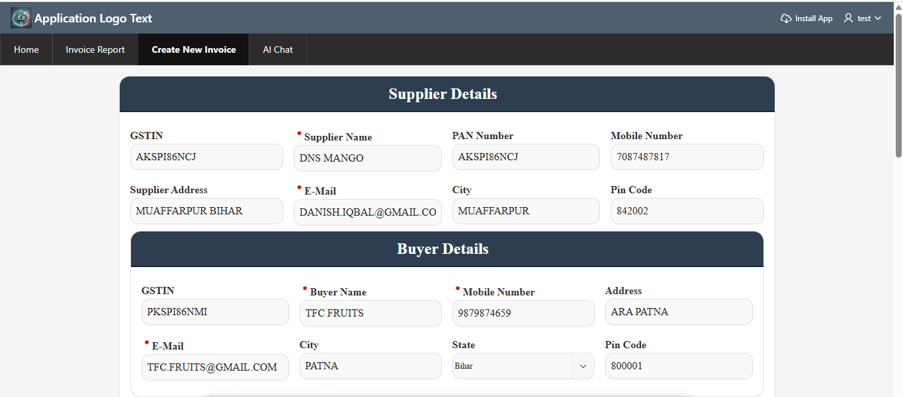
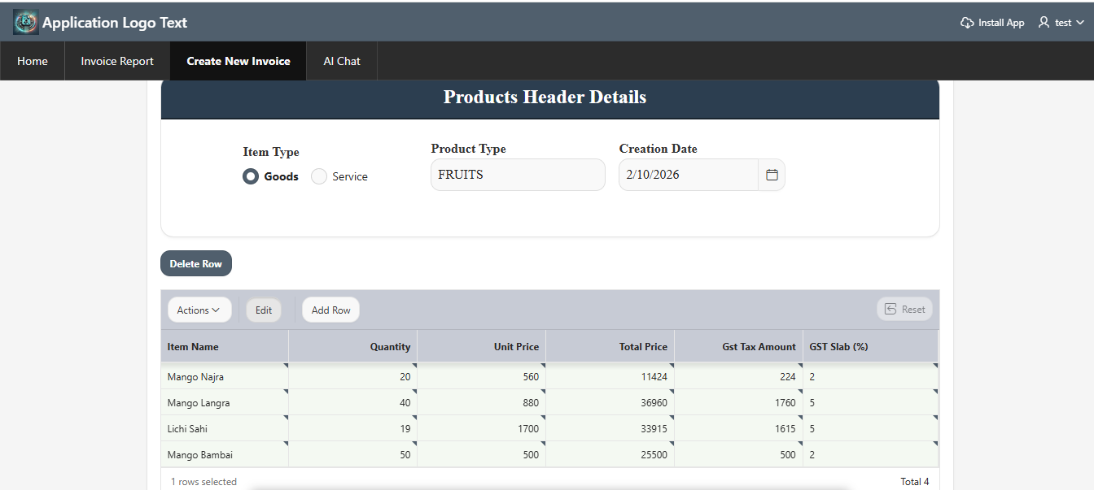
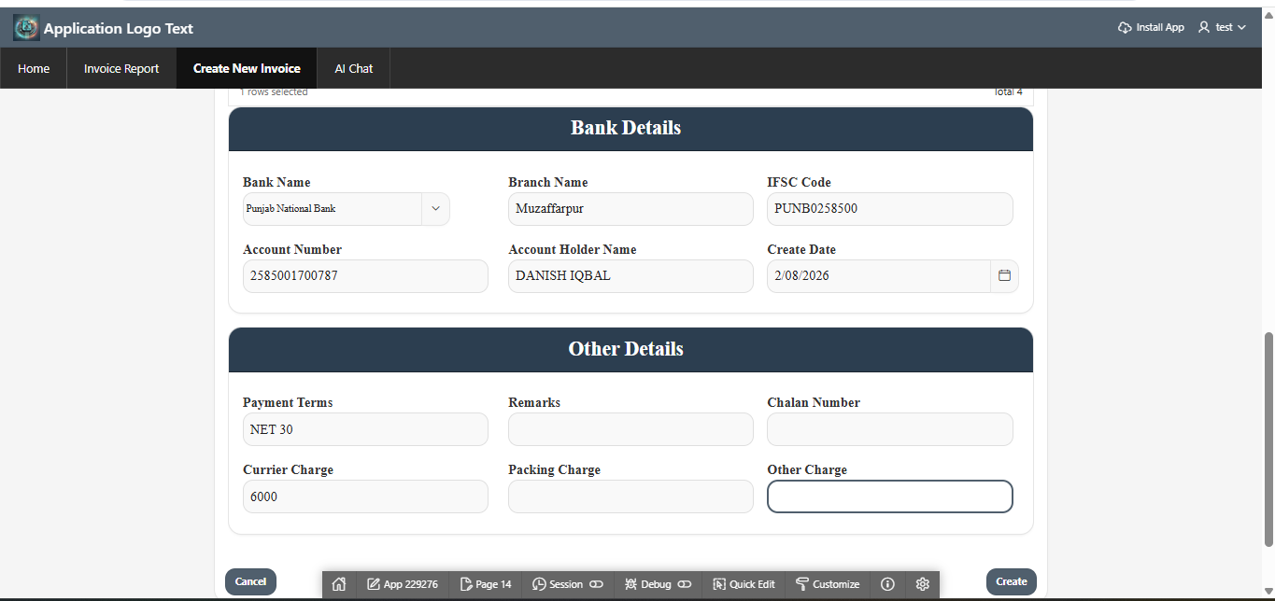
Print Invoice
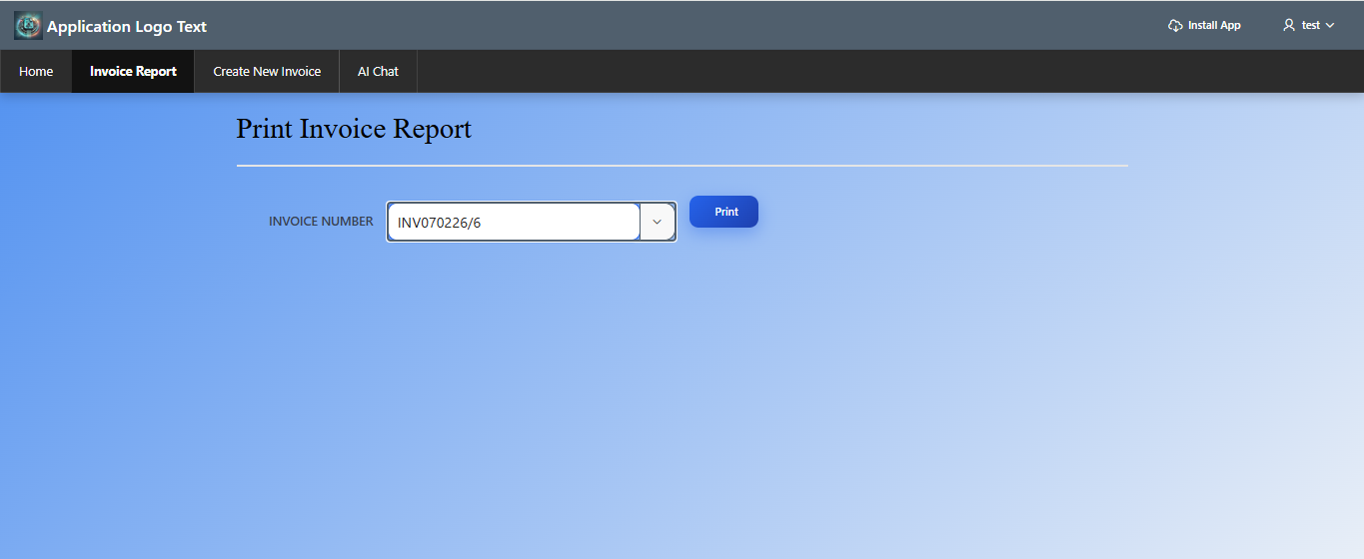
Invoice Report
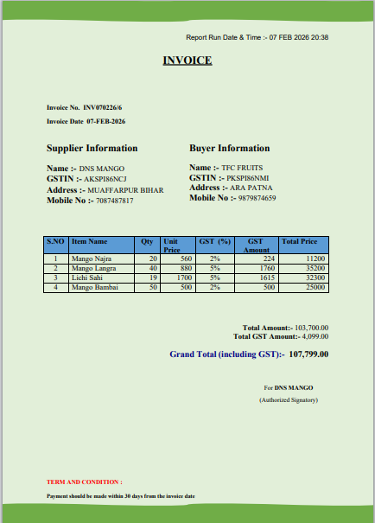
AI Assistant for Invoice Quries
